Project Design Phase
Problem – Solution Fit Template

Date | 28 September 2026
Team ID | 6ab221341
Project Name | Implement Client Script & UI Policy (Incident)
Maximum Marks | 2 Marks

Problem – Solution Fit Template:
In ServiceNow, users may enter incomplete, incorrect, or irrelevant information while creating or updating records. This can cause data inconsistencies, validation errors, and an inefficient user experience. Forms may also contain fields that are not relevant to a particular situation, making them complex and difficult to use.
Solution
The proposed solution is to implement Client Scripts and UI Policies in ServiceNow to dynamically control the behavior of form fields. Client Scripts can validate user inputs and perform client-side actions, while UI Policies can make fields visible, hidden, mandatory, or read-only according to specified conditions.
Problem–Solution Fit
The implementation of Client Scripts and UI Policies directly addresses the identified problems by improving form behavior, reducing unnecessary data entry, and guiding users to provide the required information. This improves data accuracy, usability, and the efficiency of ServiceNow forms.
Purpose:
☐ Reduce incorrect and incomplete data entry.
☐ Improve the usability and user experience of ServiceNow forms.
☐ Make important fields mandatory when required.
☐ Control field visibility and read-only behavior based on conditions.
☐ Validate user inputs and provide appropriate form-level actions.
☐ Maintain accurate and consistent information across records.
☐ Simplify forms by displaying relevant information to users.

Template:
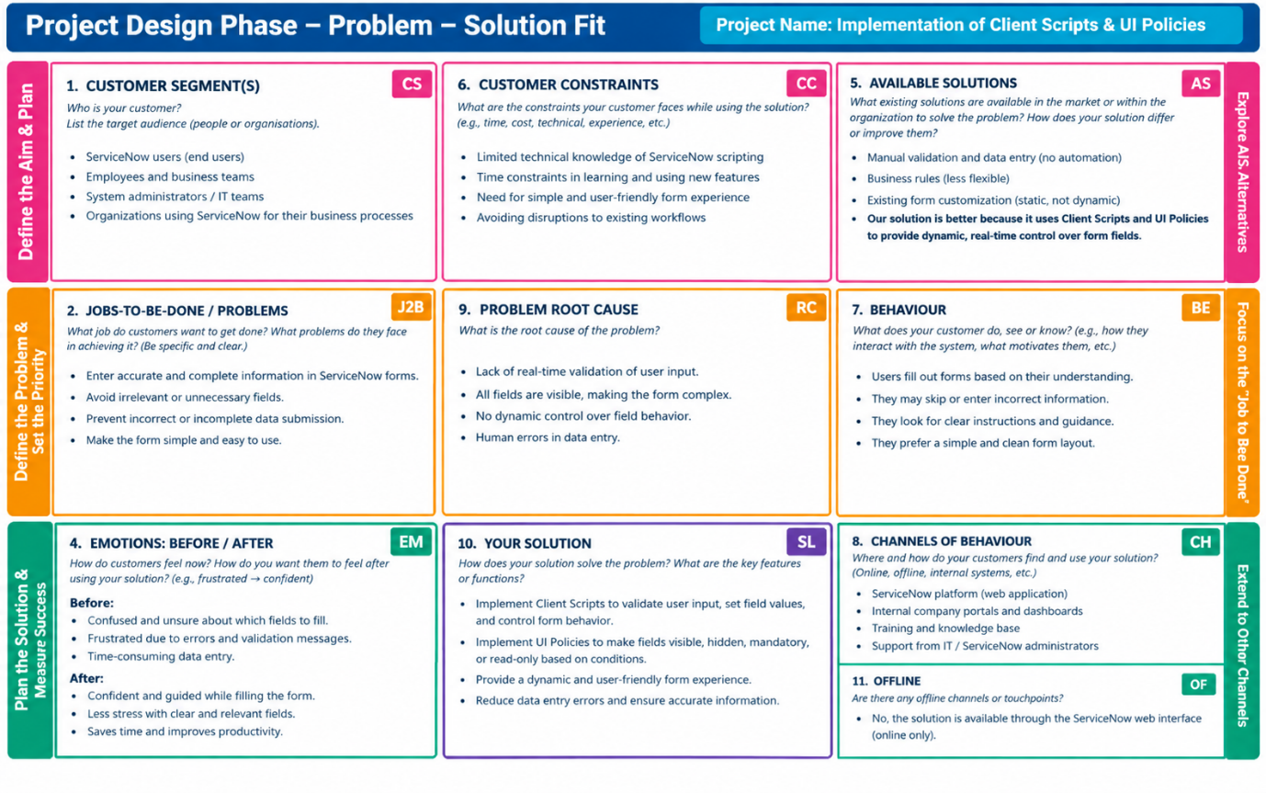
References:
- https://www.servicenow.com/docs/r/api-reference/scripts/client-scripts.html
- https://www.servicenow.com/docs/r/pt-BR/platformadministration/t_CreateAUIPolicy.html

